 

IOT BASED HEALTH CARE MONITORING SYSTEM FOR ARMY SOLDIERS

# A PROJECT REPORT

***Submitted by***

|  |  |
| --- | --- |
| **SHAIK KHANIYA** | **111520106141** |
| **THUMATI ARCHANA** | **111520106165** |
| **VADDI HARSHITHA**  **VOOTLA JAYA SAI LAKSHMI** | **111520106167**  **111520106178** |

***in partial fulfillment for the award of the degree***

***of***

**BACHELOR OF ENGINEERING**

*in*

# ELECTRONICS AND COMMUNICATION ENGINEERING

**R.M.D. ENGINEERING COLLEGE (An Autonomous Institution)**

MARCH 2024

R.M.D ENGINEERING COLLEGE (An Autonomous Institution)

**BONAFIDE CERTIFICATE**

Certified that this project report **“IoT BASED HEALTH CARE MONITORING SYSTEM FOR ARMY SOLDIERS”** is the bonafide work of **“SHAIK KHANIYA (111520106141), THUMATI ARCHANA (111520106165), VADDI HARSHITHA (111520106167), VOOTLA JAYA SAI LAKSHMI (111520106178)** who carried out the project work under my supervision.

# SIGNATURE

# Dr.K.HELENPRABHA PROFESSOR

**HEAD OF THE DEPARTMENT DEPARTMENT OF ELECTRONICS AND COMMUNICATION ENGINEERING**

# R.M.D. ENGINEERING COLLEGE

# R.S.M. NAGAR, KAVARAIPETTAI-601206

**SIGNATURE**

**Dr.K.HelenPrabha**

**SUPERVISOR**

**Professor & Head of the Department** **DEPARTMENT OF ELECTRONIC**

**AND COMMUNICATION**

**ENGINEERING**

# R.M.D ENGINEERING COLLEGE R.S.M. NAGAR, KAVARAIPETTAI - 601206

The Viva-Voce Examination for the students who have submitted this

project work is held on .........................

**INTERNAL EXAMINER EXTERNAL EXAMINER**

**ACKNOWLEDGEMENT**

At the outset, we would like to express our gratitude to our beloved and respected **Thiru. R.S. MUNIRATHINAM, Chairman, R.M.D. Engineering College**. We would like to thank **Thiru. R.M. KISHORE, B.E., M.B.A, Vice Chairman** for his encouragement, and our deepest gratitude for **Dr.N.ANBUCHEZHIAN**, **B.E., M.S.,M.E., M.B.A., Ph.D,** **Principal** for his support during the course of the project.

We take this opportunity to give profound and heartfelt thanks to the Head of the Department of Electronics and Communication, **Dr.K. HELENPRABHA,** **B.E., M.E., Ph.D**,for her constant encouragement during the project, providing all the facilities, guidance and valuable suggestions to complete the project successfully and punctually.

Our sincere thanks to our Internal Guide **Dr. K. Helen Prabha,** **B.E.,** **M.E., Ph.D, Professor and Head of the Department of Electronics and Communication** for having extended her fullest co-operation and guidance. We also thank her for her constant support and patience.

We also thank our **Parents** for their unparalleled love and moral support & finally the **Almighty** for showering his generous blessings on us, without whom we would have not gone this far.

Last, but not the least, we wish to thank all the teaching and non- teaching staff members of Electronics and Communication Engineering Department, for their blessings and constant support throughout our dissertation.

# ABSTRACT

Military is the backbone for the countries to restrict the entry of

terrorists and maintain peace inside the country. They use plenty of

electronic gadgets to fight the terrorists and protect the border. During critical conditions, they may get attacked. But due to lack of first aid during such time may cause them their life.

Even though they have communication medium it is impossible to monitor their body condition. So some soldiers can get physical illness during these conditions. It is not possible for the militants to continuously monitor the condition of the soldiers.

The combination of IoT with data analytics is the suggested way of performing this as it allows systems to work together using sensors, connection methods, internet protocols, databases, cloud computing, and analytics as infrastructure. In this respect, it is necessary to establish the technical infrastructure and a suitable environment for the development of smart hospitals.

This project aims to achieve these goals of quality care to soldiers through automatic continuous health monitoring by combining IoT data analytics with sensor technology. Modern wearable technologies have enabled continuous recording of condition of the soldiers with the help of embedded sensors integrated in the jacket would provide maximum convenience and the opportunity to monitor both the body parameters.

# TABLE OF CONTENTS

|  |  |  |
| --- | --- | --- |
| **CHAPTER**  **NO** | **TITLE** | **PAGE**  **NO** |
|  | **ACKNOWLEDGEMENT** | III |
|  | **ABSTRACT** | IV |
|  | **TABLE OF CONTENTS** | V |
| **1** | **LIST OF FIGURES**  **LIST OF ABBRIVETIONS**  **INTRODUCTION** | VII  VIII  1 |
| **2** | **LITERATURE SURVEY** | 4 |
| **3** | **PROPOSED SYSTEM** | 6 |
|  | 3.1 Existing System | 6 |
|  | 3.2 Existing System Disadvantages | 6 |
|  | 3.3 Proposed System | 7 |
|  | 3.4 Block Diagram | 7 |
|  | 3.4.1 Soldiers Unit | 8 |
|  | 3.4.2 Base Station Unit | 8 |
| **4** | **PROJECT DESCRIPTION** | 10 |
|  | 4.1 Working | 10 |
|  | 4.2 Hardware Requirements | 10 |
|  | 4.2.1 Microcontroller | 11 |
|  | 4.2.2 Power Supply | 13 |
|  | 4.2.3 LM358 – Heartbeat sensor | 15 |
|  | 4.2.4(a) Temperature Sensor  4.3.4(b) Humidity Sensor | 17  18 |

* + 1. Respiratory Sensor 19
    2. IOT MODULE 21
    3. LCD Display 23
  1. Software Requirements 25
     1. Arduino IDE 25
     2. Embedded C 28

1. RESULTS 31
2. CONCLUSION AND FUTURE

ENHANCEMENTS 34

REFERENCES 36

**LIST OF FIGURES**

# FIGURE NO FIGURE NAME PAGE NO

* 1. Internet Of Things (IoT) 1
  2. Sensor Technology 2
     1. Block Diagram 7
     2. ESP32 11
     3. DC Adapter 14
     4. LM358 – Heartbeat Sensor 16

4.2.4 (a) LM35 – Temperature Sensor 17

* + 1. (b) DHT11 – Humidity Sensor 18
    2. Respiratory sensor 19
    3. (a) Webserver 21

4.2.6 (b) Controlling Section 22

* + 1. LCD Display 23
    2. Arduino IDE 25
  1. Inputs to the System 31
  2. Receiver System 31
  3. Display Unit 32

# LIST OF ABBREVIATIONS

|  |  |  |
| --- | --- | --- |
| **S.NO** | **ABBREVIATION** | **EXPANSION** |
| 1 | IoT | Internet of Things |
| 2 | AI | Artificial Intelligence |
| 3 | QoS | Quality Of Service |
| 4 | LCD | Liquid Crystal Display |
| 5  6 | Wi-Fi  GPS | Wireless Fidelity  Global positioning system |
| 7  8  9  10  11  12  13 | LoRa  DHT  PWM  LDR  LED  DDR  LVDS | Long Range  Dihydrotestosterone  Pulse Width Modulation  Light Dependent Resistor  Light Emitting Diode  Double Data Rate  Low Voltage Differential Signaling |
|  |  |  |

**CHAPTER 1 INTRODUCTION**

Internet of Things (IoT) technology has a wide variety of applications and the use of the Internet of Things is growing so faster. Depending upon different application areas of the Internet of Things, it works accordingly as per it has been designed/developed. But it has not a standard defined architecture of working which is strictly followed universally. The architecture of IoT depends upon its functionality and implementation in different sectors.

This technology connects everyday objects such as sensors, actuators, and things to the Internet via existing networks to facilitate the diagnosis and follow-up of patients while increasing the efficient use of hospital resources. IoT applications are developed to use this connected network, relying on a digital environment. This offers new opportunities to provide fast and accurate responses by obtaining relevant information.

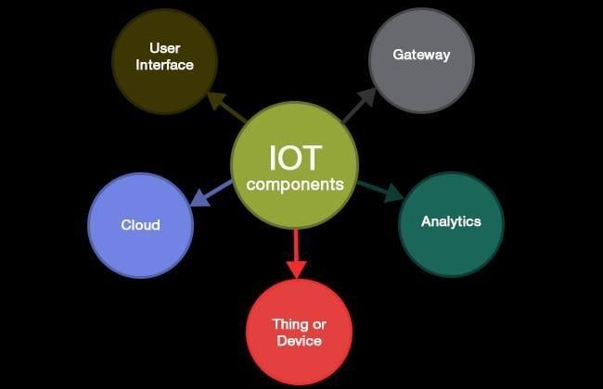

* 1. Internet of Things (IoT)

This intelligent network can receive data from several sources, and process data locally using the decreased computing power in a centralized manner with higher digital computing resources to make smarter decisions. From this, intelligent recommendations, predictive analysis, or pattern detection can be made. With these intelligent abilities, IoT technology also enables the improvement of Quality of Service (QoS).

IoT Data Analytics, or simply IoT analytics is the act of analyzing data generated and collected from IoT devices by utilizing a specific set of data analytics tools and techniques. The true idea behind IoT data analytics is to turn vast quantities of unstructured data from various devices and sensors within the Internet of Things ecosystem, which is heterogeneous, into valuable and actionable insights for driving sound business decision-making and further data analysis.

Furthermore, IoT analytics enables identifying the patterns in data sets, including both current states and historical data, which can be utilized to make predictions and adjustments about future events.

And the process of IoT analytics includes a series of steps given below

* Determine the use cases
* Data collection
* Data storage
* Data visualization
* Data Analysis

Sensors Technology plays a key role when we use it in IoT. The sensor is a device that detects changes in an environment or measures physical property, record, indicates, or respond to it. so, different types of applications require different types of sensors to data from the environment.

Sensor technology in IoT makes it possible to collect data in almost any situation. For instance, We use sensors in medical care, nursing care, industrial, logistics, transportation, agriculture, disaster prevention, tourism, regional businesses, and many more. In other words, With the expansion of the fields in which sensors play an essential role, the market is still growing with various sensors.

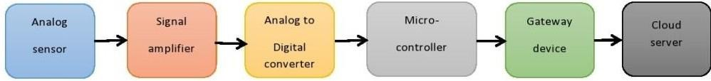

* 1. Sensor Technology

3

1

.

There are various kinds of UAV devices seen nowadays used by technically developed countries for their soldiers. Previously used technologies are outdated and use outdated technology which needs continuous surveillance and the performance is also not as expected. The project proves to be very beneficial in determining the health status of the soldier. The heartbeat, which is very much important for determining the health status of a person is easily been calculated by this system and if found inappropriate, the data would be send directly to the control station and is informed about the same. Another important feature i.e. measurement of temperature sensor is also very much beneficial for determining health status. If the soldier is suffering from fever, then it would be also detected and informed at the control station about the same.

# CHAPTER 2 LITERATURE SURVEY

**REAL TIME WIRELESS EMBEDDED ELECTRONICS FOR SOLDIER**

**SECURITY-** **Bhargav Jethwa, Milit Panchasara** said that they present a WSN-based environmental and health monitoring approach in which sensor data is processed using robust and stable algorithm implemented in controller. These processed data are then sent to the base station via low-cost, lowpower and secure communication links provided by a LoRa network infrastructure instead of cellular networks, since, they are either absent or doesn’t allow data transmission in warzone or remote areas. We focus on monitoring environmental factors such as temperature, humidity, air pressure, air quality; physical factors such as motion, position, geographic location and health parameters like ECG (electro cardiograph), blood oxygen level, body temperature.

**HEALTH MONITORING OF SOLDIERS USING EFFICIENT MANET**

**PROTOCOL–** **G. Santhanamari , Premi J** said that Information technology plays a key role in collecting, exchanging, and processing information from the

disaster-prone areas like war field and international borders. One such significant role is to monitor the health condition of the soldiers in the war field remotely to ensure their safety. The data transmission in these areas is not reliable over wired connections. This paper focuses on designing a health monitoring system which transmits the data such as health parameters of soldiers like temperature, pulse rate, blood oxygen level and Electro Cardio Gram (ECG) over a Mobile Ad hoc Network (MANET) with an efficient routing protocol through nRF24L01 to the control room. The efficient protocol is identified by comparing the different MANET protocols simulated using OMNET++.

**DEVELOPING A SECURE SOLDIER MONITORING SYSTEM USING**

**INTERNET OF THINGS AND BLOCK CHAIN- Jitesh Pabla, Vaibhav Sharma** said that Currently, a state’s army is considered a vital tool for its security. Therefore, tracking and monitoring the health and position of a soldier becomes necessary to ensure their safety. In recent years, a lot of technological advances happen in the field of sensors. One of the popular areas utilizing sensors is developing human healthcare system to monitor vital body signals. The network of such sensors that are used to monitor vital human signal for health care is called Body Sensor Network (BSN). Similarly, a small GPS module can be used to track a person’s location.

**NO SOLDIERS LEFT BEHIND: AN IOT-BASED LOW- POWER MILITARY MOBILE HEALTH SYSTEM DESIGN–James Jin Kang, Wenchang Yang, Gordana Dermody** said that There has been an increasing prevalence of ad-hoc networks for various purposes and applications. These include Low Power Wide Area Networks (LPWAN) and Wireless Body Area Networks (WBAN) which have emerging applications in health monitoring as well as user location tracking in emergency settings. This has potential benefits for military networks and applications regarding the health of soldiers and field personnel during a mission. An inference system can be applied to devices to reduce data size for transfer and subsequently reduce battery consumption, however this could result in compromising accuracy. This paper presents a framework for secure automated messaging and data fusion as a solution to address the challenges of requiring data size reduction whilst maintaining a satisfactory accuracy rate. A Multilayer Inference System (MIS) was used to conserve the battery power of devices such as wearable's and sensor devices. The results for this system showed a data reduction of 97.9% whilst maintaining satisfactory accuracy against existing single layer inference methods

# CHAPTER 3 PROPOSED SYSTEM

* 1. **EXISTING SYSTEM**
     + A Helmet mounted visitors , capable of displaying maps and real time video from other squad members.
     + A smart health monitoring system to monitor various parameters of the patient based on standard values

# Existing System Disadvantages

* + - The system heavily relies on various technological components such as wireless networks, physiological sensors, and real-time video feeds. Any malfunction or disruption in these components could significantly hamper operational effectiveness.
    - Integrating multiple piecemeal components into a lightweight package increases the complexity of the system. This complexity can lead to maintenance issues, difficulties in troubleshooting, and potentially longer training periods for soldiers to fully understand and utilize the equipment effectively.
    - With multiple integrated components, there's an increased risk of technical malfunctions or failures, which could compromise the safety and effectiveness of soldiers in the field. Malfunctions in critical components like the physiological sensors or wireless communication systems could result in inaccurate data or loss of connectivity.
    - Operating the helmet-mounted visor system effectively requires specialized training. Soldiers must be proficient in using the various features and interpreting the data provided by the system. This could add to the overall training burden and potentially limit the accessibility of the technology to less experienced personnel.

# PROPOSED SYSTEM

A smart jacket for monitoring the body parameters of soldiers with web based communication. The jacket is interfaced with sensors which are continuously fetching the physical parameters of the soldier such as heartbeat, respiratory rate and body temperature along with environmental temperature. These vital parameters are continuously updated in IOT along with location. Every status will be displayed in LCD.

# Block Diagram

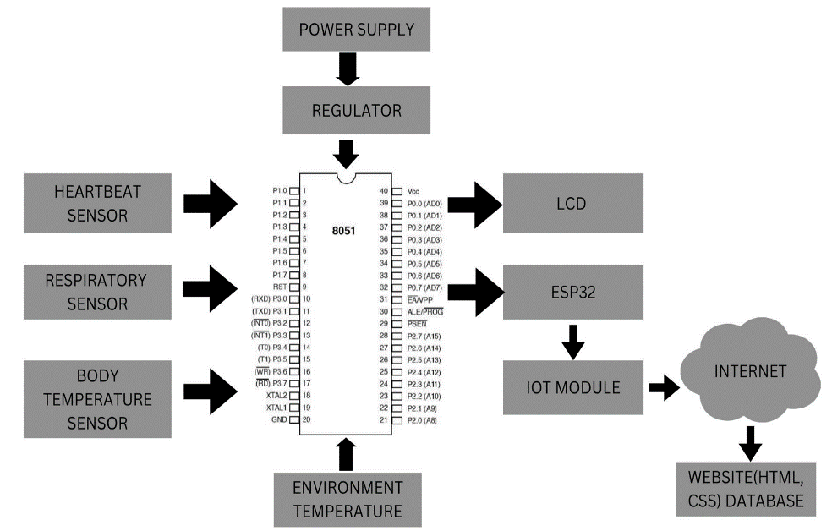

3.4 Block Diagram

**HARDWARE REQUIREMENTS:**

* MICROCONTROLLER
* POWER SUPPLY
* HEARTBEAT SENSOR
* RESPIRATORY SENSOR
* TEMPERATURE SENSOR
* IOT MODULE
* LCD

**SOFTWARE REQUIREMENTS:**

* ARDUINO IDE
* EMBEDDED C

**3.4.1 Soldiers Unit**

In this unit a ESP32 microcontroller is used to collect the data from different sensors attached to the soldier’s body through the jacket. Along with them a GPS sensor is placed to track the location. This sensor provides NMEA (National Marine Electronics Association) raw data, which is used to extract the coordinates of the soldier. The beat sensor is placed directly on skin just below the sternum. The respiratory sensor is placed around the abdomen area. The temperature sensor placed outside the jacket to measure the temperature.

Similarly, in the case of environmental temperature sensor. For the GPS module along with those connections we need to connect the TX pin to digital input of micro controller and RX pin to digital output of microcontroller. Now the micro controller setup is connected to the LCD through IOT . The ESP32 acts both as a microcontroller and IOT module.

# Base Station unit

After all the sensors are connected and placed in the jacket. Each sensor communicates with the ESP32 to provide data, and this data is then formatted and displayed on an LCD screen. The Pulse Sensor library can be used to obtain heart rate readings, while the DHT and additional DHT libraries can be employed for temperature readings. With the Pulse Sensor library, the ESP32 can capture heart rate data, offering insights into cardiovascular health. Temperature readings from DHT sensors provide information about the body's thermal state, and the respiratory rate sensor monitors breathing patterns. The inclusion of a GPS module enables location tracking, which can be crucial for applications in the military or emergency response scenarios. A respiratory rate sensor provides information about breathing, and a GPS module, using the TinyGPS++ library, provides location data .

The soldier unit, equipped with various sensors such as heart rate monitors, temperature sensors, accelerometers, and GPS trackers, continuously collects physiological and environmental data. This data is then processed locally within the soldier unit to extract relevant health metrics and contextual information. Subsequently, the soldier unit employs a wireless communication protocol to transmit this processed data to the base station unit. The base station, typically stationed at a command center or medical facility, acts as a receiver for the transmitted data. Upon receiving the data packets, the base station unit decodes and interprets the information, analyzing vital signs, detecting anomalies, and assessing the soldier's health status in real-time.

Additionally, the base station may incorporate machine learning algorithms to predict potential health risks or emergencies based on the collected data. This bidirectional communication enables seamless monitoring and timely intervention, ensuring the well-being and safety of the soldiers in various operational environments. Moreover, the base station unit may also transmit commands or alerts back to the soldier unit, providing instructions or warnings based on the analyzed data, thus establishing a robust communication link for effective health monitoring and management in the field.

# Working

**CHAPTER 4 PROJECT DESCRIPTION**

An automatic system is proposed to monitor the patient’s body temperature, pulse rate, Respiratory rate, and environment temperature. The ESP32's setup function initializes the sensors and sets up serial communication with the GPS module. Additionally, the display is configured, ensuring proper functionality. The loop function reads data from each sensor and displays it on the LCD screen. This process repeats at a regular interval, allowing real-time monitoring of multiple health parameters. It's essential to note that this is a generalized overview, and the actual implementation may vary based on the specific sensors, LCD, and libraries you are using.

# Hardware Requirements

* + - MICROCONTROLLER (ESP32)
    - POWER SUPPLY
    - HEARTBEAT SENSOR
    - TEMPERATURE SENSOR
    - RESPIRATORY SENSOR
    - IOT MODULE
    - LCD

# 4.2.1 ESP32 MICROCONTROLLER

ESP32 is a series of low-cost, low-power system on a chip microcontrollers with integrated Wi-Fi and dual-mode Bluetooth. The ESP32 series employs either a Tensilica Xtensa LX6 microprocessor in both dual-core and single-core variations, Xtensa LX7 dual-core microprocessor or a single-core RISC-V microprocessor an d includes built-in antenna switches, RF balun, power amplifier, low-noise receive amplifier, filters, and power-management modules. ESP32 is created and developed by Espressif Systems, a Shanghai-based Chinese company, and is manufactured by TSMC using their 40 nm process.

Another important thing to know about ESP32 is that it is manufactured using TSMC’s ultra-low-power 40 nm technology. So, designing battery operated applications like wearables, audio equipment, baby monitors, smart watches, etc., using ESP32 should be very easy.

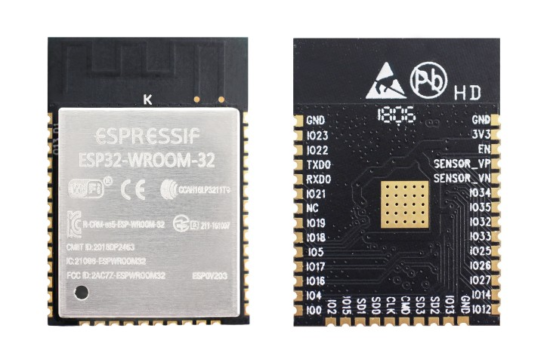

* + 1. ESP32

**SPECIFICATIONS:**

* Single or Dual-Core 32-bit LX6 Microprocessor with clock frequency up to 240 MHz.
* 520 KB of SRAM, 448 KB of ROM and 16 KB of RTC SRAM.
* Supports 802.11 b/g/n Wi-Fi connectivity with speeds up to 150 Mbps.
* Support for both Classic Bluetooth v4.2 and BLE specifications.
* 34 Programmable GPIOs.
* Up to 18 channels of 12-bit SAR ADC and 2 channels of 8-bit DAC
* Serial Connectivity include 4 x SPI, 2 x I2C, 2 x I2S, 3 x UART.
* Ethernet MAC for physical LAN Communication (requires external PHY).
* 1 Host controller for SD/SDIO/MMC and 1 Slave controller for SDIO/SPI.
* Motor PWM and up to 16-channels of LED PWM.
* Secure Boot and Flash Encryption.
* Cryptographic Hardware Acceleration for AES, Hash (SHA-2), RSA, ECC and RNG.

ESP32 has a lot more features than ESP8266 and it is difficult to include all the specifications in this Getting Started with ESP32 guide. So, a list of some of the important specifications of ESP32 here.

# POWER SUPPLY(ADAPTER)

# GENERAL DESCRIPTION

An adapter is a device that converts attributes of one electrical device or system to those of an otherwise incompatible device or system. Some modify power or signal attributes, while others merely adapt the physical form of one electrical connector to another. In a computer, an adapter is often built into a card that can be inserted into a slot on the computer's motherboard. The card adapts information that is exchanged between the computer's microprocessor and the devices that the card supports.

**PRODUCT DESCRIPTION**

An electric power adapter may enable connection of a power plug, sometimes called, used in one region to a AC power socket used in another, by offering connections for the disparate contact arrangements, while not changing the voltage. An AC adapter, also called a "recharger", is a small power supply that changes household electric current from distribution voltage) to low voltage DC suitable for consumer electronics. Some modify power or signal attributes, while others merely

adapt the physical form of one electrical connector to another. For computers and related items, one kind of serial port adapter enables connections between 25-contact and nine-contact connectors, but does not affect electrical power- and signaling-related attributes. Back-end systems which need to send purchase order data to oracle applications send it to the integration service via integration server client.

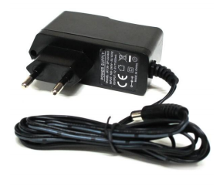

4.2.2 DC Adapter

**FEATURES:**

* Output current:1A
* Supply voltage: 220-230VAC
* Output voltage: 12VDC
* Reduced costs
* Increased value across front-office and back-office functions
* Access to current, accurate, and consistent data
* It generates adapter metadata as WSDL files with J2CA extension

**APPLICATIONS:**

* Back-end systems which need to send purchase order data to oracle applications send it to the integration service via integration server client.
* SMPS applications.

# HEARTBEAT SENSOR

HEART BEAT sensor is designed to give digital output of heat beat when a finger is placed on it. When the HEART BEAT detector is working, the beat LED flashes in unison with each heart beat. This digital output can be connected to microcontroller directly to measure the Beats Per Minute (BPM) rate. As Sensor a photo diode or a photo transistor can be used. The skin may be illuminated with visible (red) using transmitted or reflected light for detection. The very small changes in reflectivity or in transmittance caused by the varying blood content of human tissue are almost invisible.

It works on the principle of light modulation by blood flow through finger at each pulse. HEART BEAT is sensed by using a high intensity type LED and LDR. The finger is placed between the LED and LDR. As Sensor a photo diode or a photo transistor can be used. The setup described here uses a red LED for transmitted light illumination and a LDR as detector. With only slight changes in the preamplifier circuit the same hardware and software could be used with other illumination and detection concepts.

Medical heart sensors are capable of monitoring vascular tissue through the tip of the finger or the ear lobe. It is often used for [health](http://www.ehow.com/health/) purposes, especially when monitoring the body after physical training. HEART BEAT is sensed by using a high intensity type LED and LDR. The finger is placed between the LED and LDR. As Sensor a photo diode or a photo transistor can be used. The skin may be illuminated with visible (red) using transmitted or reflected light for detection. The very small changes in reflectivity or in transmittance caused by the varying blood content of human tissue are almost invisible.

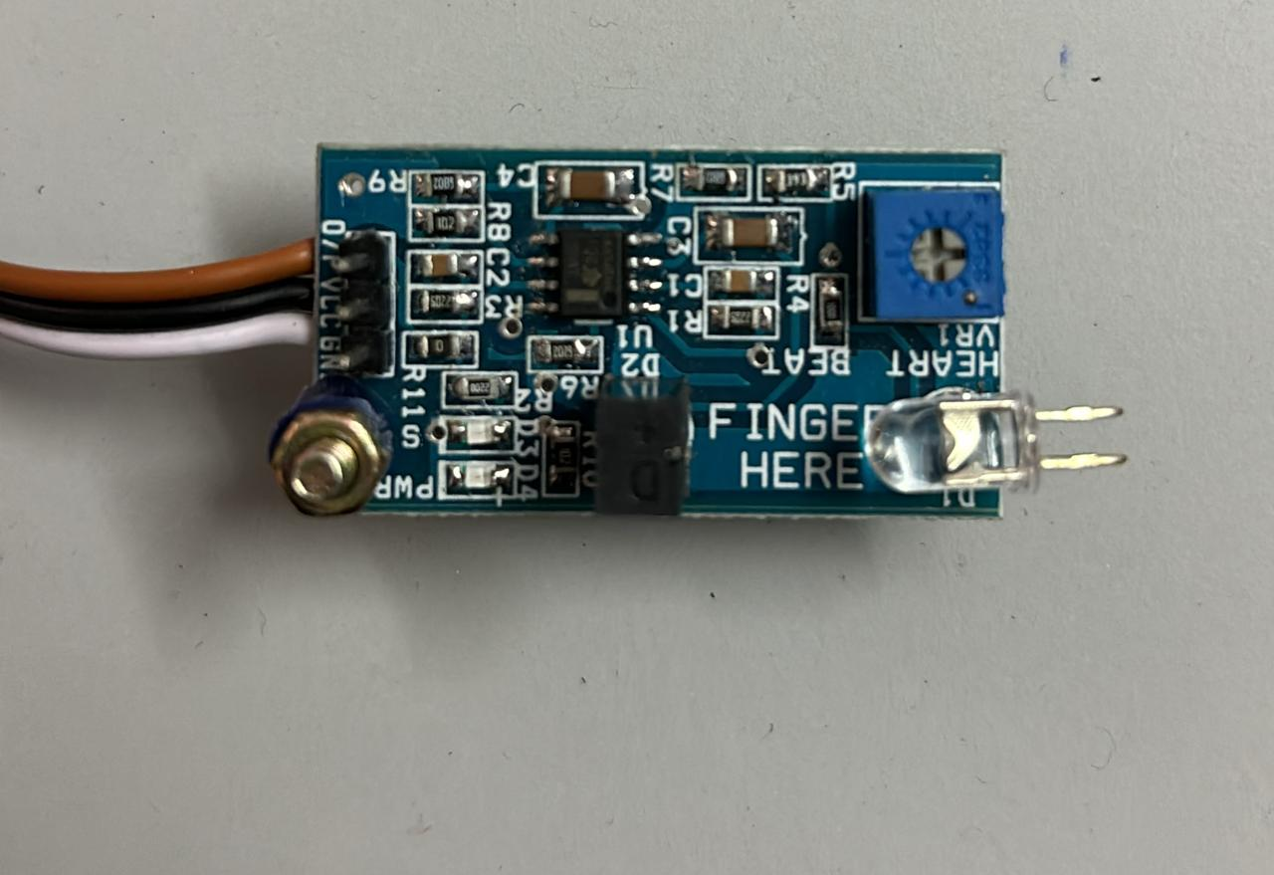

* + 1. LM358

**FEATURES :**

* Microcontroller based SMD design
* Heat beat indication by LED
* Instant output digital signal for directly connecting to microcontroller
* Compact Size
* Working Voltage +5V DC

**APPLICATIONS:**

* Digital Heart Rate monitor
* Patient Monitoring System
* Bio-Feedback control of robotics and applications.

# 4.2.4 (a) TEMPERATURE SENSOR

The LM35 series are precision integrated-circuit temperature devices with an output voltage linearly proportional to the Centigrade temperature. The LM35 device has an advantage over linear temperature sensors calibrated in Kelvin, as the user is not required to subtract a large constant voltage from the output to obtain convenient Centigrade scaling. The LM35 device does not require any external calibration or trimming to provide typical accuracies of ±¼°C at room temperature and ±¾°Cover a full −55°C to 150°C temperature range. Lower cost is assured by trimming and calibration at the wafer level.

The low-output impedance, linear output, and precise inherent calibration of the LM35 device make interfacing to readout or control circuitry especially easy. The device is used with single power supplies, or with plus and minus supplies. As the LM35 device draws only 60 μA from the supply, it has very low self-heating of less than 0.1°C in still air.The LM35 device is rated to operate over a −55°C to 150°C temperature range, while the LM35C device is rated for a −40°C to 110°C range (−10° with improved accuracy).The LM35D device is available in an 8-lead surface-mount small-outline package . The LM35 is used for measurement of soldier’s body temperature.

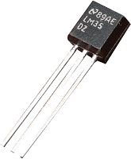

4.2.4(a) LM35

**FEATURES**

* Operates from 4 V to 30 V
* Less than 60-µA Current Drain
* Linear + 10-mV/°C Scale Factor
* 0.5°C Ensured Accuracy (at 25°C)
* Rated for Full −55°C to 150°C Range

**4.2.4(b) HUMIDITY SENSOR**

The humidity sensor is used for measurement of environmental temperature. A humidity sensor (or hygrometer) senses, measures, and reports both moisture and air temperature. The ratio of moisture in the air to the highest amount of moisture at a particular air temperature is called relative humidity. Relative humidity becomes an important factor when looking for comfort.

The applications of humidity sensor range far and wide. People with illnesses affected by humidity, monitoring and preventive measure in homes employ humidity sensors. A humidity sensor is also found as part of home heating, ventilating and air conditioning systems (HVAC systems). These are also used in offices, cars, humidors, museums, industrial spaces and greenhouses and are also used in meteorology stations to report and predict the weather.

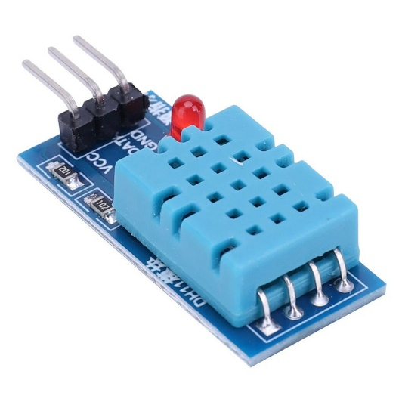

4.2.4(b) DHT11

# RESPIRATORY SENSOR

The Respiration Sensor is used to monitor abdominal or thoracically breathing, in biofeedback applications such as stress management and relaxation training. Besides measuring breathing frequency, this sensor also gives you an indication of the relative depth of breathing. The Respiration Sensor for Nexus can be worn over clothing, although for best results we advise that there only be 1 or 2 layers of clothing between the sensor and the skin. The Respiration Sensor is usually placed in the abdominal area, with the central part of the sensor just above the navel. The sensor should be placed tight enough to prevent loss of tension.

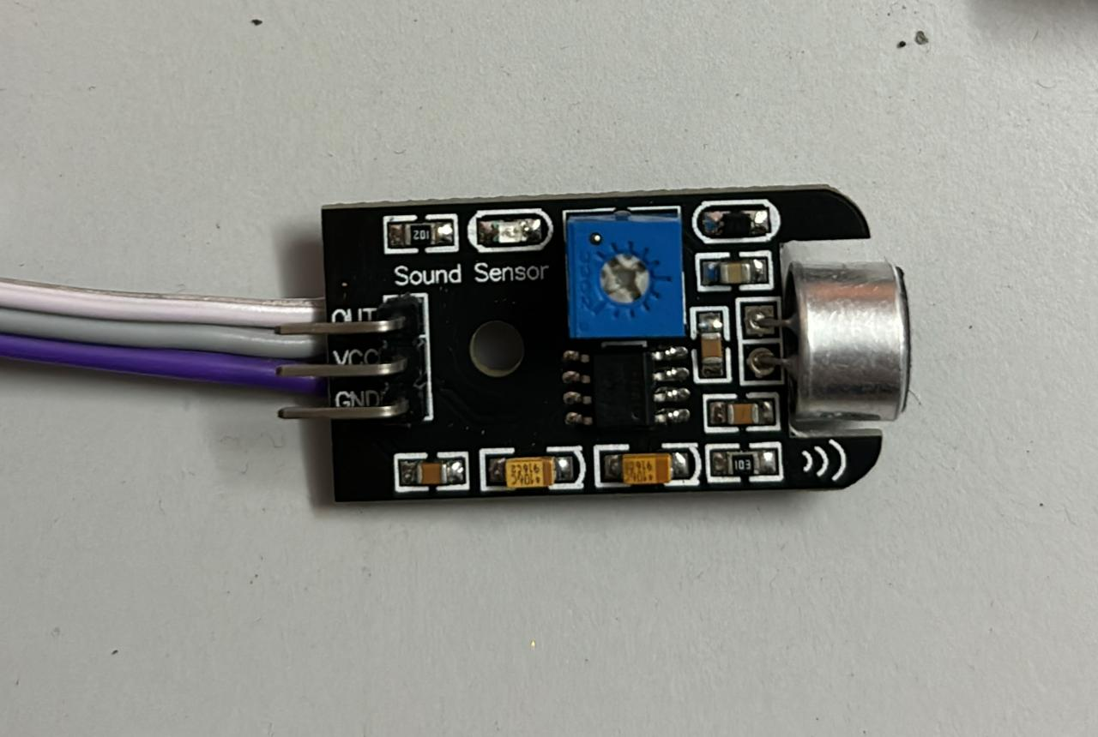

4.2.5 Respiratory sensor

First Sensor develops and manufactures highly reliable sensors and customized sensor systems as a strategic partner to medical product manufacturers in the area of breathing and respiration. The first step in this process is breathing in air, or inhaling. The taking in of air rich in oxygen into the body is called inhalation and giving out of air rich in carbon dioxide from the body is called exhalation.

The second step is gas exchange in the lungs where oxygen is diffused into the blood and the carbon dioxide diffuses out of the blood. The third process is cellular respiration, which produces the chemical energy that the cells in the body need, and carbon dioxide. Finally, the carbon dioxide from cellular respiration is breathed out of body from the lungs.

**FEATURES:**

* Input voltage: 5v
* Output voltage: 5v
* Output: Analog
* Range: 30% – 65%
* Size (Approx.):132cm (52" Long)

**APPLICATIONS:**

* Medical purpose
* Environmental Control System
* Emergency response System

# 4.2.6 IOT MODULE

The Internet of things (IoT) is the network of everyday objects — physical things embedded with electronics, software, sensors, and connectivity enabling data exchange. Basically, a little networked computer is attached to a thing, allowing information exchange to and from that thing. Be it lightbulbs, toasters, refrigerators, flower pots, watches, fans, planes, trains, automobiles, or anything else around you, a little networked computer can be combined with it to accept input (especially object control) or to gather and generate informational output (typically object status or other sensory data). This means computers will be permeating everything around us ubiquitous embedded computing devices, uniquely identifiable, interconnected across the Internet. Because of low-cost, networkable microcontroller modules, the Internet of things is really starting to take off.

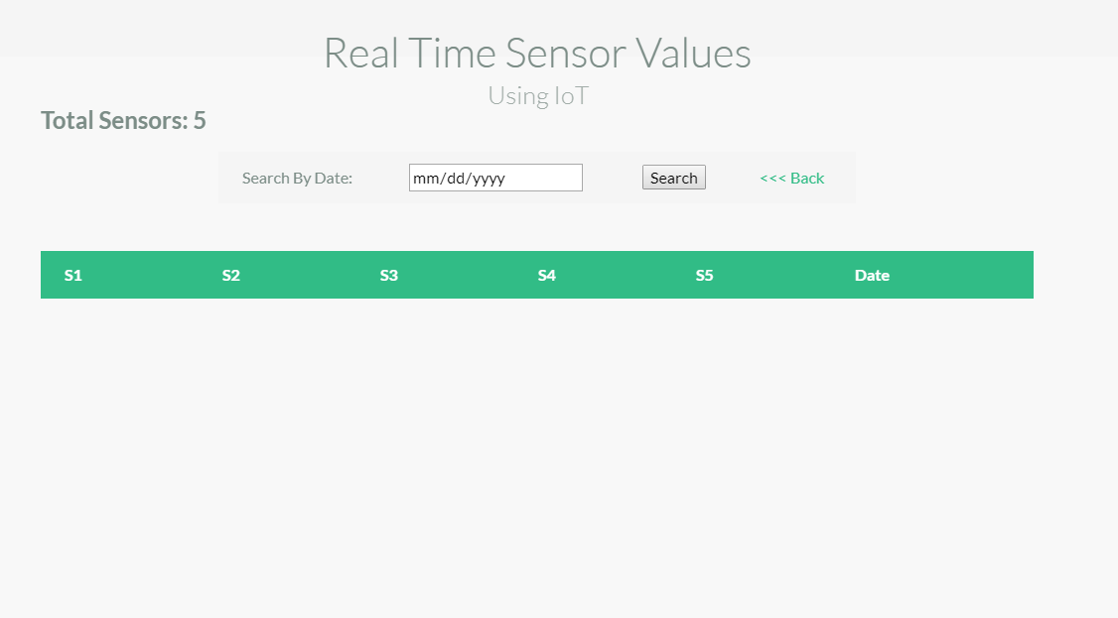

4.2.6(a) Web Server

Espressif Systems’ Smart Connectivity Platform (ESCP) enables sophisticated features including fast switch between sleep and wakeup mode for energy-efficient purpose, adaptive radio biasing for low-power operation, advance signal processing, spur cancellation and radio co-existence mechanisms for common cellular, Bluetooth, DDR, LVDS, LCD interference mitigation.

**Channel Frequencies:**

The RF transceiver supports the following channels according to IEEE802.11b/g/n standards.

**WEB SERVER: Controlling Section**

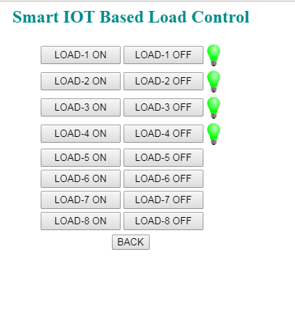

4.2.6(b) Controlling Section

**APPLICATIONS**

* Online Traffic monitoring
* Online Health monitoring
* Real time Transport and Logistics monitoring
* Daily life and domestics

# LCD

LCD (Liquid Crystal Display) is a type of flat panel display that uses liquid crystals in its primary form of operation. LEDs have a large and varying set of use cases for consumers and businesses, as they can be commonly found in smartphones, televisions, computer monitors, and instrument panels.

A display is made up of millions of [pixels](https://www.techtarget.com/whatis/definition/pixel). The quality of a display commonly refers to the number of pixels; for example, a 4K display is made up of 3840 x2160 or 4096x2160 pixels. A pixel is made up of three subpixels; red, blue, and green—commonly called [RGB](https://www.techtarget.com/whatis/definition/RGB-red-green-and-blue). When the subpixels in a pixel change color combinations, a different color can be produced. With all the pixels on a display working together, the display can make millions of different colors. When the pixels are rapidly switched on and off, a picture is created.

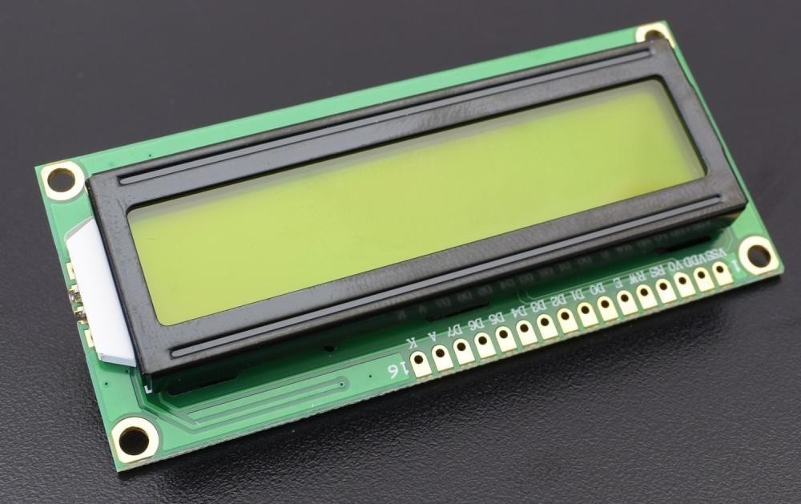

* + 1. LCD Display

The way a pixel is controlled is different in each type of display; CRT, LED, LCD, and newer types of displays all control pixels differently. In short, LCDs are

lit by a backlight, and pixels are switched on and off electronically while using liquid crystals to rotate polarized light. A polarizing glass filter is placed in front and behind all the pixels, the front filter is placed at 90 degrees. In between both filters are the liquid crystals, which can be electronically switched on and off.

LCDs are made with either a passive matrix or an active-matrix display grid. The active-matrix LCD is also known as a thin film transistor ([TFT](https://www.techtarget.com/whatis/definition/thin-film-transistor-TFT)) display. The passive matrix LCD has a grid of conductors with pixels located at each intersection in the grid. A current is sent across two conductors on the grid to control the light for any pixel. An active matrix has a [transistor](https://www.techtarget.com/whatis/definition/transistor) located at each pixel intersection, requiring less current to control the luminance of a pixel. For this reason, the current in an active-matrix display can be switched on and off more frequently, improving the screen refresh time.

Some passive matrix LCDs have dual scanning, meaning that they scan the grid twice with the current at the same time that it took for one scan in the original technology. However, the active matrix is still a superior technology out of the two.

**FEATURES:**

* Input voltage: 5v
* E-blocks compatible
* Low cost
* Compatible with most I/O ports in the E-Block range
* Ease to develop programming code using Flow code icons

**APPLICATIONS:**

* Monitoring

# Software Requirements

* + - ARDUNIO IDE
    - EMBEDDED C

# 4.3.1 ARDUNIO IDE

The Arduino Integrated Development Environment – or Arduino Software (IDE) – contains a text editor for writing code, a message area, a text console, a toolbar with buttons for common functions, and a series of menus. It connects to the Arduino hardware to upload programs and communicate with them. Programs written using Arduino Software (IDE) are called sketches.These sketches are written in the text editor and are saved with the file extension. In. The editor has features for cutting/pasting and searching/replacing text.

# [ArduinoLaunch.png](http://www.robotc.net/wikiarchive/File:ArduinoLaunch.png)

4.3.1 ARDUNIO IDE

The message area gives feedback while saving and exporting and also displays errors. The console displays text output by the Arduino Software (IDE), including complete error messages and other information. The bottom righthand corner of the window displays the configured board and serial port. The toolbar buttons allow you to verify and upload programs, create, open, and save sketches, and open the serial monitor.

**Summary**

## Microcontroller Arduino UNO

Operating Voltage 5V Input Voltage (recommended)

Input Voltage (limits) 6-20V

Digital I/O Pins 54 (of which 14 provide PWM output)

Analog Input Pins 16

DC Current per I/O Pin 40mA

DC Current for3.3VPin 50mA

Flash Memory 256 KB of which 8 KB used by bootloader

SRAM 8KB

EEPROM 4KB

Lock Speed 16MHz

The Arduino UNO can be powered via the USB connection or with an external power supply. The power source is selected automatically. External (non-USB) power can come either from an AC-to-DC adapter (wall-wart) or battery. The adapter can be connected by plugging a 2.1mm center-positive plug into the board's power jack. Leads from a battery can be inserted in the Gnd and Vin pin headers of the POWER connector.

The board can operate on an external supply of 6 to 20 volts. If supplied with less than 7V, however, the 5V pin may supply less than five volts and the board may be unstable. If using more than 12V, the voltage regulator may overheat and damage the board. The recommended range is 7 to 12 volts.

**Communication**

The Arduino UNO has a number of facilities for communicating with a computer, another Arduino, or other microcontrollers. The Arduino UNO provides four hardware UARTs for TTL (5V) serial communication.

An ATMEGA on the board channels one of these over USB and provides a virtual comport to software on the computer (Windows machines will need a .inf file, but OSX and Linux machines will recognize the board as a COM port automatically. The Arduino software includes a serial monitor which allows simple textual data to be sent to and from the board. The RX and TX LEDs on the board will flash when data is being transmitted via the ATmega8U2 chip and USB connection to the computer (but not for serial communication on pins 0 and1).

A [Software Serial library](http://www.arduino.cc/en/Reference/SoftwareSerial) allows for serial communication on any of the digital pins. The Arduino UNO also supports I2C (TWI) and SPI communication. The Arduino software includes a Wire library to simplify use of the I2C bus; see the [documentation on the Wiring website](http://wiring.org.co/reference/libraries/Wire/index.html) for details. To use the SPI communication, please see the Arduino UNO datasheet.

**Programming**

The Arduino UNO can be programmed with the Arduino software ([download](http://arduino.cc/en/Main/Software)). For details, see the [reference](http://arduino.cc/en/Reference/HomePage) and [tutorials](http://arduino.cc/en/Tutorial/HomePage).

The Arduino UNO on the Arduino UNO comes preburned with a [bootloader](http://arduino.cc/en/Tutorial/Bootloader) that allows you to upload new code to it without the use of an external hardware programmer. It communicates using the original STK500 protocol ([reference](http://www.atmel.com/dyn/resources/prod_documents/doc2525.pdf), [C header files](http://www.atmel.com/dyn/resources/prod_documents/avr061.zip)).

You can also bypass the bootloader and program the microcontroller through the ICSP (In-Circuit Serial Programming) header; see [these instructions](http://arduino.cc/en/Hacking/Programmer) for details.

**Physical Characteristics and Shield Compatibility**

The Arduino UNO has a resettable poly fuse that protects your computer's USB ports from shorts and over current. Although most computers provide their own internal protection, the fuse provides an extra layer of protection. If more than 500mA is applied to the USB port, the fuse will automatically break the connection until the short or overload is removed.

The maximum length and width of the UNO PCB are 4 and 2.1 inches respectively, with the USB connector and power jack extending beyond the former dimension. Three screw holes allow the board to be attached to a surface or case. Note that the distance between digital pins 7 and 8 is 160 mil (0.16"), not an even multiple of the 100-mil spacing of the other pins.

The UNO is designed to be compatible with most shields designed for the Diecimila or Duemilanove. Digital pins 0 to 13 (and the adjacent AREF and GND pins), analog inputs 0 to 5, the power header, and ICSP header are all in equivalent locations. Further the main UART (serial port) is located on the same pins (0 and 1), as are external interrupts 0 and 1 (pins 2 and 3 respectively). SPI is available through the ICSP header on both the Mega and Duemilanove / Diecimila.

**4.3.2 EMBEDDED C**

Embedded C is designed to bridge the performance mismatch between Standard C and the embedded hardware and application architecture. It extends the C language with the primitives that are needed by signal-processing applications and that are commonly provided by DSP processors. The design of the support for fixed-point data types and named address spaces in Embedded C is based on DSP-C. DSP-C is an industry-designed extensionof C with which experience was gained since 1998 by various DSP manufacturers in their compilers.

For the development of DSP-C by ACE (the company three of us work for), cooperation was sought with embedded-application designers and DSP manufacturers. The Embedded C specification extends the C language to support freestanding embedded processors in exploiting the multiple address space functionality, user-defined named address spaces, and direct access to processor and I/O registers.

These features are common for the small, embedded processors used in most consumer products. The features introduced by Embedded C are fixed-point and saturated arithmetic, segmented memory spaces, and hardware I/O addressing. The description we present here addresses the extensions from a language-design perspective, as opposed to the programmer or processor architecture perspective.

Here are some key characteristics and considerations of Embedded C:

**Memory Constraints:** Embedded systems often have limited memory, so efficient memory usage is crucial. Embedded C programmers must be mindful of memory allocation and deallocation, avoiding unnecessary memory usage.

**Real-time Constraints:** Many embedded systems require real-time operation, meaning they must respond to events within specific time constraints. Embedded C programmers often use techniques like interrupts, scheduling, and prioritization to meet real-time requirements.

**Hardware Interaction:** Embedded systems interact closely with hardware components such as microcontrollers, sensors, actuators, and communication interfaces. Embedded C provides mechanisms to directly access hardware registers and perform low-level operations, allowing developers to control and interface with hardware efficiently.

**Portability:** While Embedded C is often specific to particular microcontroller architectures or platforms, efforts are made to maintain portability across different embedded systems. Standardized C libraries such as CMSIS (Cortex Microcontroller Software Interface Standard) help achieve this portability by providing consistent APIs for various microcontroller families.

**Compiler and Toolchain Considerations:** Embedded C code is typically compiled using specialized compilers and toolchains optimized for embedded systems. These tools often provide features like code optimization, memory layout control, and debugging support tailored for embedded development.

**Low-Level Programming:** Embedded C programmers often work at a low level, directly manipulating memory addresses, configuring hardware peripherals, and optimizing code for performance and resource usage. This requires a solid understanding of both the C language and the underlying hardware architecture.

**Testing and Debugging:** Testing embedded systems can be challenging due to the limited resources and real-time requirements. Embedded C programmers use techniques like unit testing, hardware-in-the-loop (HIL) testing, and debugging tools provided by the development environment to ensure the reliability and correctness of their code.

**Power Consumption Optimization:** Many embedded systems are battery-powered or have strict power constraints. Embedded C programmers optimize code to minimize power consumption, often using techniques like sleep modes, clock gating, and efficient algorithms.

# 

# 5.1 Inputs to the System

# 

**CHAPTER 5 RESULTS**

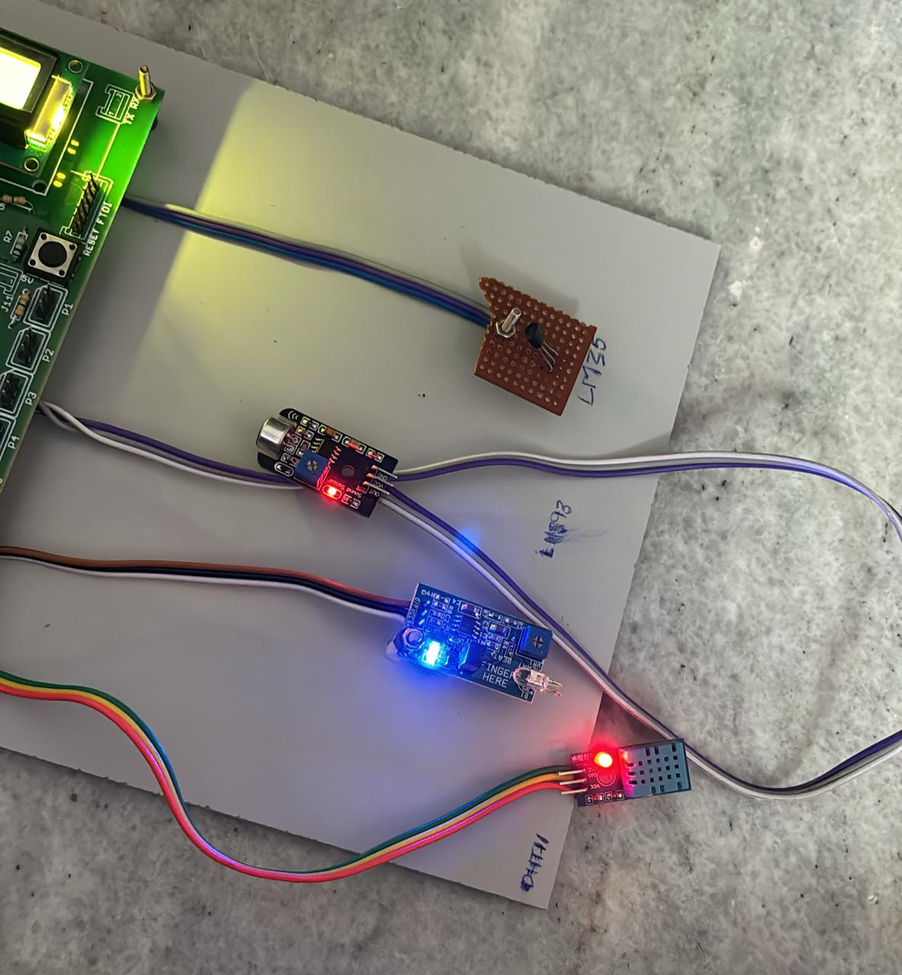

* 1. Inputs to the System

# Receiver System

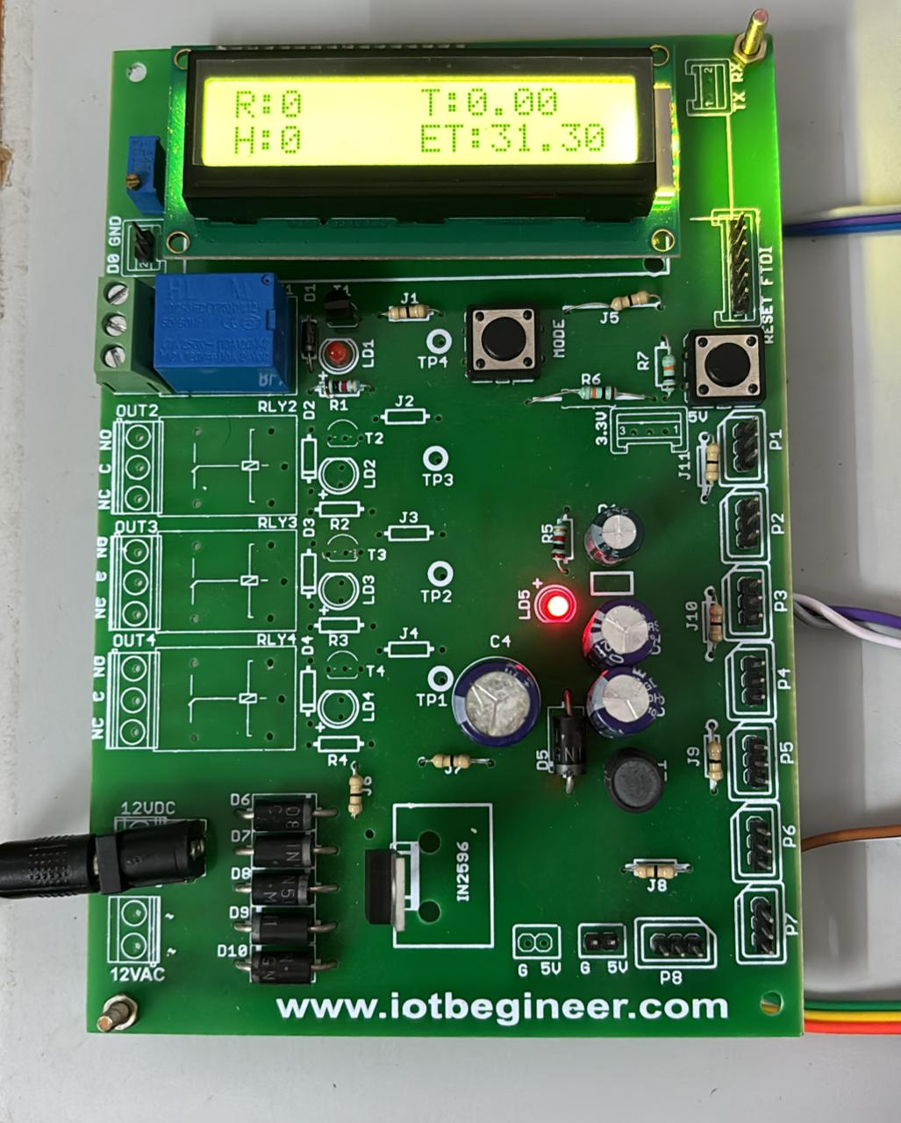

* 1. Receiver System

# Display Unit

All the data that is getting stored in the cloud will be displayed dynamically through the LCD Display. And all the body parameters of the solder will be updates on the server for every second.

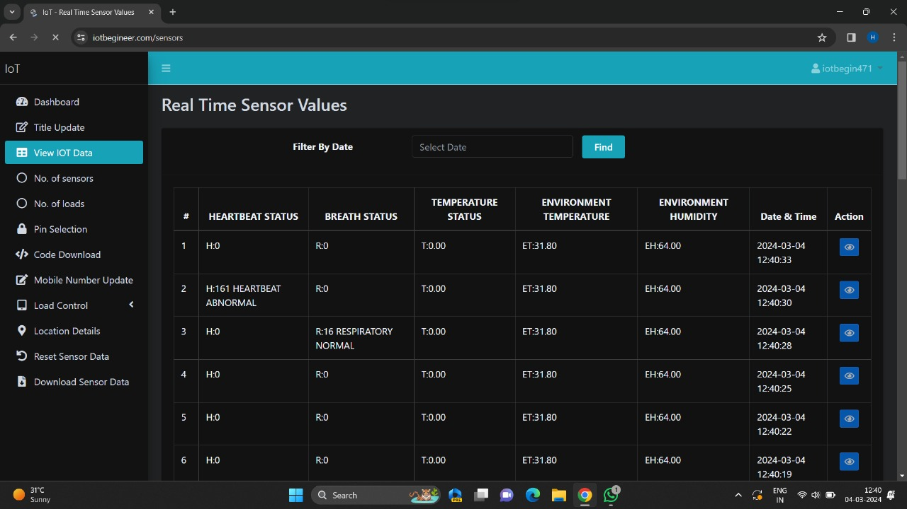

* 1. Display Unit

Initially, all the parameters are recorded and maintained at room temperature. Depending upon the patient’s input data, the data storage and data display take place parallelly.

This when the soldiers any of the body parameters changes with respect to his condition they will be updates on the server. As we can observe above diagram the abnormal or the normal state of the solider is being displayed.

This makes it easy for the control room to understand the health condition of the solider and respective measures can be taken to save him. The date and time are also changed to keep the record of soldier’s health condition. Displaying the vital parameters on an LCD screen provides instant feedback to the soldier wearing the jacket. This allows them to monitor their own health status and take necessary precautions if any parameter deviates from the normal range.

It also serves as a quick reference for medical personnel who may need to assess the soldier's condition on-site. The continuous collection of data over time allows for analysis and insights into long-term trends and patterns. This can be valuable for identifying potential health risks, optimizing training regimes, and improving overall soldier performance and well-being.

# CHAPTER 6

**CONCLUSION AND FUTURE ENHANCEMENTS**

The project reports an IoT based system for the health monitoring and tracking of the soldiers. Biomedical sensors provide heartbeat, body temperature, and environmental parameters of every soldier to control room. This technology can be helpful to provide the accurate location of missing soldier in critical condition and overcome the drawback of soldiers missing in action.

The developed system will improve the current health monitoring system that may protect lots of lives from death. The system looks somewhat complicated, it will be a tiny device with proper manufacturing shortly. Thus, the concerns like quality care, staffing concerns providing best support to the soldier’s health monitor.

The addressing system is also helpful to improve the communication between soldier to soldier in emergency situation and provide proper navigation to control room. Thus, we can conclude that this system will act as a lifeguard to the army personnel of all over the globe. In future, a portable handheld sensor device with more sensing options may be developed to aid the soldiers.

Real-time event instances are monitored for computing event adversity. In the future, we will further optimize and design the model based on existing research, and finally, it can be applied to the market.

As technology continues to advance and become increasingly integrated into our daily lives, projects like this serve as a testament to the transformative power of innovation. By harnessing the capabilities of IoT and data-driven analytics, we can revolutionize how we monitor, manage, and improve health outcomes for individuals, whether they are soldiers on the battlefield or patients in a hospital bed. This project represents a significant step forward in realizing the potential of technology to enhance human well-being and underscores the importance of continued investment in research and development at the intersection of healthcare and technology.

**Future Enhancements include**

* The video feature can be added for face-to-face consultation between doctors and patients.
* We can add a GPS module in IOT patient monitoring using the Arduino Uno and the Wi-Fi module project. This GPS module will find out the position or the location of the patient using the longitude and latitude

received. Then it will send this location to the cloud which is the IOT using the Wi-Fi module. Then doctors can find out the position of the patients in case they have to take some preventive action.

* Implementing robust privacy and security measures to protect the sensitive health data collected by the smart jacket from unauthorized access or cyber threats. This includes encryption protocols, secure data storage practices, and adherence to relevant regulations such as GDPR and HIPAA.

**REFERENCES**

[1] International Institute for Strategic Studies (3 February 2014). The Military Balance 2014, pp. 241–246. London: Routledge. ISB 9781857437225.

[2] "Press Information Bureau". pib.nic.in.

[3] P. Kumar, G. Rasika, V.Patil, and S. Bobade, “Health Monitoring and Tracking of Soldier Using GPS,’’ International Journal of Research in Advent Technology, vol.2, no.4, pp. 291-294, Apr. 2014.

[4] S. Sharma, S. Kumar, A. Keshari, S. Ahmed, S. Gupta and A. Suri, "A Real Time Autonomous Soldier Health Monitoring and Reporting System Using COTS Available Entities," Second International Conference on Advances in Computing and Communication Engineering (ICACCE), Dehradun-India, May 2015, pp. 683-687.

[5] R. Kumar and M. Rajasekaran, "An IoT based patient monitoring system using raspberry Pi," International Conference on Computing Technologies and Intelligent Data Engineering, Kovilpatti-India,Jan. 2016, pp. 1-4.

[6] R. Shaikh,’’ Real Time Health Monitoring System of Remote Patient Using Arm7,’’ International Journal of Instrumentation, Control and Automation (IJICA), vol. 1, no. 3-4, pp.102-105, 4, 2012.

[7] D. Kumar and S.Repal, “Real Time Tracking and Health Monitoring of Soldiers using ZigBee Technology: a Survey,” International Journal of Innovative Research in Science, Engineering and Technology, vol. 4, no.7, pp. 5561-5574, Jul. 2015.

[8] G. Raj and S. Banu, “GPS Based Soldier Tracking And Health Indication System With Environmental Analysis “International Journal of Enhanced Research in Science Technology& Engineering, vol. 2, no. 12, pp. 46-52, Dec. 2013.

[9] V. Ashok, T. Priyadarshini, and S.Sanjana, “A Secure Freight Tracking System in Rails Using GPS Technology” Second International Conference on Science Technology Engineering and Management (ICONSTEM), Chennai, India Mar. 2016, pp. 47- 50.

[10] M..Jassas, A . Abdullah.and H. Mahmoud, “A Smart System Connecting e-Health Sensors and the Cloud” IEEE 28thCanadian Conference on Electrical and Computer Engineering Halifax, Canada, May 2015, pp.712-716.